**Résumé 1 – Part 5**

**Résolution symbolique, résolution numérique d’équations et de systèmes d’équations**

**Rappels et compléments en équations différentielles**

**3- Laplace Transforms: Reminders and Complements**

There are many good reasons to use the Laplace transform and the following example provides an answer to this question.

**4.1 Example:** A tank initially contains 500 L of a saline solution of concentration 2 kg/L. During the first 10 minutes, a valve A is opened, resulting in the injection of 12 L/min of saline solution of concentration 4 kg/L. After 10 minutes, the B-valve provides 6 kg/L of concentration at a rate of 12 L/min. An outlet valve C allows 12 L/min to flow out and thus keeps the volume constant. The task is to find the concentration of salt in the tank as a function of time.

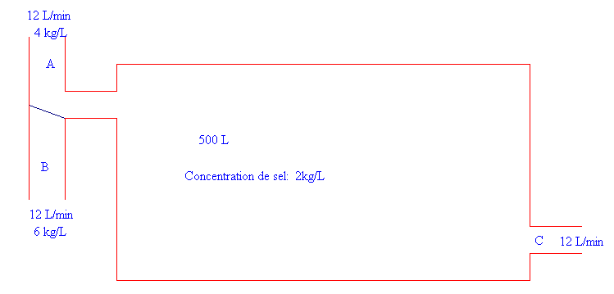

**Figure 4.1**

This is the answer: 

Here are some good reasons (there are others) to use the Laplace transform:

This avoids, when solving differential equations with piecewise continuous input, to perform several integrals and to adjust each time the integration constants. From an analytical point of view, the Laplace transformation realizes a correspondence between functional spaces and from an operational point of view, we pass from a differential equation to an algebraic equation. One can introduce "impulse" functions for which indeterminate coefficient and/or parameter variation techniques are ineffective.

So, let's recall some definitions, some properties and prove some results not proven in an undergraduate differential equations course.

**4.2 Definitions:** Let *f* be a function defined for t ≥ 0. We say that this function is of exponential order for *t* → ∞ if there are non-negative constants *M*, *c* and *T* satisfying  So if the improper integral



Is convergent for some values of *s* then its result is a function called the Laplace transform of *f*. The linear operator that associates function *f* with function *F* is called Laplace transformation and is denoted here by :



We usually denote the correspondence by . The inverse Laplace transform is obtained by solving the integral equation (we will see how the complex variables allow us to obtain this result). A common notation in mathematics books is to use *u*(*t*) to denote the step-unit function (or Heaviside function), namely



We find that 

**4.3 Example:** "Mini table"of Laplace transforms.

For each of the following functions *f* (right column in the table below), the improper integral (19) converges if we choose *s* > *a* and we find the *F*(*s*) indicated in the left column: using the factorization in  and the partial fraction technique, we don't need a large "table" of Laplace transforms, the one given in figure 4.2 is very useful for example. If repeated irreducible quadratic factors are present, convolution can be used (see below).

|  |  |
| --- | --- |
| *F*(*s*) | *f*(*t*) |
|  |  |
|  |  |
|  |  |

**Figure 4.2**

By abuse of notation, we often write or  in order to indicate the correspondence . Voici une table plus complète de transformées de Laplace :

<https://cours.etsmtl.ca/seg/ctrottier/265/laplace-table.pdf>

**4.4 Remark:** The Gamma function Γ is defined by and this improper is convergent for *x* > 0.

In particular, this function satisfies the following properties:

.

**4.5 Definitions:**

We say that a function f is piecewise continuous on an interval [*a*, *b*] if we can subdivide the interval into a finite number of subintervals such that *f* is continuous on each of the open subintervals and if *f* has limits at each end of these subintervals (limit on the right (resp. on the left) for the left (resp. right) end). We say that *f* is piecewise continuous on [0, ∞[, if *f* is piecewise continuous on each bounded subinterval of [0, ∞[. The jump of *f* at point *c* is noted asand defined by



**4.6 Theorem**

**a) Sufficient condition (but not necessary) for the existence of the Laplace transform**

If *f* is piecewise continuous for *t* ≥ 0 and of exponential order for *t*, then the Laplace transform of *f* exists for *s* > *c*. Si *f* est continue par morceaux pour *t* ≥ 0 et d’ordre exponentiel pour *t* → ∞, alors la transformée de Laplace de *f* existe pour *s* > *c*. Moreover, .

**b) Uniqueness of the inverse transform "almost everywhere"**

If *f* and g satisfy the assumptions in a) and if *F*(*s*) = *G*(*s*) for all *s* > *c*, then *f*(*t*) = *g*(*t*) everywhere on   
[0, ∞[, where *f* and *g* are continuous.

**c) Transform of the derivative**

If *f* is continuous, piecewise derivable for *t* ≥ 0 and of exponential order for *t*, then the Laplace transform of *f* exists and we have



**d)** If, in c), f is only piecewise continuous, with discontinuities (finite jumps) localized at points and if is the jump of *f*(*t*) in , then, assuming that the transform of *f‘* exists, then we have



Proof :Proof of b) will follow from the inversion theorem in complex analysis. Let’s prove a).

If *b* > 0, then



and therefore, .

For c) and d), we will show that exists and we will find its limit. If *b* is fixed, let   
*t*1, *t*2, …, *tk*–1 the points inside the interval [0, *b*] where the function *f* could be discontinuous by jumps. Let’s set  Then, we can use integration by parts on each open interval where *f’* is continuous and obtain





where is zero because *f* is continuous at  In addition, if *b* > *c,* then So, the result is established, letting *b* tend to infinity. ♦

**4.7 Example**

Let us illustrate parts c) and d) of Theorem 4.6. Consider the following two functions: *f*1 which is continuous everywhere and piecewise derivable and *f*2 which is piecewise continuous (and also piecewise derivable) but with a jump of 1 at *t* = 1.



It is easy to find their respective Laplace transforms since  whereas :

 

While the derivatives are the following and equal (without using generalized functions):



By calculating the Laplace transforms, since  we get



Theorem 4.6 c) is well satisfied  since



It is identical. Theorem 4.6 c) is satisfied because since



Students who are familiar with generalized functions can use them. For example if we take the function *f*(*t*) = *u*(*t* - 1), then we have and Theorem 4.6 c) is satisfied since  If one does not work with generalized functions, Theorem 4.6 d) applies: then we have then except at *t* = 1 where the derivative does not exist and the jump at *t* = 1 is 1. And 

**4.8 Other Important Properties**

From Theorem 4.6 c), we derive, if *f*(0) = 0, that . Thus, "the derivation in the domain of *t* corresponds to the multiplication in the domain of *s*". We have the "dual" property: the integration in the *t*-domain corresponds to the division in the *s*-domain:

 .

In addition, the translation and convolution properties are frequently used; in the following, *u*(*t*) denotes the Heaviside step-unit function and :

|  |  |
| --- | --- |
|  |  |
|  |  |
|  |  |

**Figure 4.3**

This is the integral given in the previous table in Figure 4.3 and is called the "convolution of functions *x* and *h*" and is often denoted as . A proof of the convolution property is following. At the beginning let us notice that the convolution is commutative since, by change of variables, we can write



We have, using the definition of the Laplace transform and the property of the middle row of the table above (with *a* replaced by *t*)



where we used, in the last equality, the fact that *u*(*t* - t) = 0 if *t* < *t*. If we draw the domain of integration of the last double integral, we have figure 4.4 in the *t-t* plane which covers the entire upper part of the first quadrant above the line *t* = *t* :

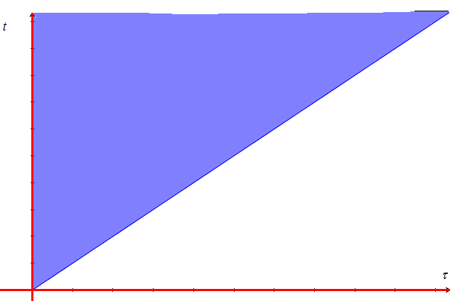

**Figure 4.4**

Considering this region as type II rather than type I, we can therefore swap the order of integration and obtain by continuing where we were



**4.9 Example: partial fractions/convolution**

By reapplying property b) of Theorem 4.6, we can, for example, solve a linear differential equation with constant coefficients using the Laplace transform. Indeed, let us consider the problem



where  denotes the derivative of order *n* of the function *y* ( = *y*) and where the *n* initial conditions have been given. So, if  we have that the DE is transformed into the algebraic equation



where *Q*(*s*) is a polynomial of degree *n*–1 in *s* which depends on the initial conditions and the coefficients of the differential equation and where *H*(*s*) = 1/*R*(*s*) is the transfer function. In fact, *R*(*s*) is the characteristic polynomial of the DE.

.

We see that .

The partial fraction technique is frequently used to invert the last function. Function *Y* is always rational if the input *x*(*t*) consists of linear combinations and products of polynomials, sines, cosines, exponentials. In the case where the input *x*(*t*) is piecewise continuous, it is sufficient to apply the same principle and the translation property.

In particular, if the initial conditions are zero (system at rest), then *Q* is identically zero and the solution of the DE is



where  is called impulse response. This response is entirely characterized by the coefficients.

**4.10 Example: Development in partial fractions**

Let be a rational proper function (deg *F* < deg *G*) and where we assume that *F* and *G* have no common factors.

**4.10.1**  If *a* is a simple zero of *G*, then the partial fractional expansion of contains a term of the form  where 

**4.10.2** If *a* is a zero of order *m* of *G*, then the partial fraction expansion of  contains expressions of the form , where

 (*k* = 1, 2, ..., *m* - 1)

**4.11 Example**

Let's find the inverse Laplace transform of the function

 .

Let *y*(*t*) be this transform. Without complex numbers, we can easily find that



and by completing the square we obtain

.

Thus, . With complex numbers, we find



A table of transforms and the Euler formulas allow us to write that



**4.12**  Now let's find the inverse Laplace transform of the function .

By factoring only in the real numbers, we have



And therefore . Calculation gives (the convolution is associative)





An "expansion in complex partial fractions" can be done by informing the Nspire system that a variable is considered complex and not real:

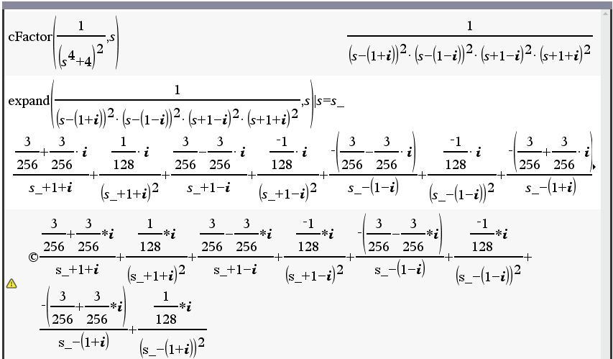

**Figure 4.5**

**4.13 Convolution and the importance of the "Dirac function"**

The differential equation of a mass-spring problem is



where *m* is the mass of the object, *b* is the damping constant, *k* is the spring constant, *y*(*t*) is the position of the object at time *t* and *f*(*t*) is the external force.

As for the RLC circuit, it is



where *R*, *L***,** *C* are the components connected in series, *E*(*t*) is the source and we have the following relations:

.

It is therefore useful to consider the following second order linear differential equation with constant coefficients and we will assume zero initial conditions (system at rest).

 (*x*(*t*) = 0 if *t* < 0)

Often, in the last differential equation, we say that *x*(*t*) is the input and *y*(*t*) is the output. By using the Laplace transform where the DE is transformed to



where .

is called transfer function (transform of the output on transform of the input). But to obtain the equality *Y* = *H*, the input *x*(*t*) would have to be such that its Laplace transform *X* is 1. However, for a "normal" function, this is impossible according to Theorem 4.6 a) … Such a "generalized" function can be obtained by considering, for example, the limits of interval indicator functions. Let's have a closer look: Given *ε* > 0, let us define a piecewise continuous function satisfying the assumptions of Theorem 4.6 a) as follows:



We easily find that  and, although does not exist in the classical sense, the *limit of the transform exists* and . For this reason, the Dirac "function" or impulse function is introduced and meets the following requirements:



where, in the last formula, function *x* is assumed to be continuous in *t* = *a*. In other words, the Dirac "function" *d*(*t* - *a*) concentrates the mass in *t* = *a* and this formula is well understood when we calculate the integral: indeed,



Consequently, if , then *h*(*t*) is entirely characterized by the coefficients of the problem and it makes sense to call *h*(*t*) the impulse response (the output when the input is an impulse). The solution of the DE is the convolution of the input and the impulse response: 

It is because of the Laplace transform, the fact of imposing zero initial conditions and of considering all functions to be zero before *t* = 0 that we could obtain the result. The linearity of the integral and the translation property (Figure 4.3, second row of the table) make the problem an example of what is called a "time-invariant linear system".

**4.14 Exemple**

Let's go back to example 3.9.2 where we were looking for the "resonance frequency", i.e. the value of *ω* that will provide a maximum steady state amplitude for the problem . Let's assume zero initial conditions since this only affects the transient regime. As the transfer function is

 ,

then the impulse response is

.

The convolution of *h*(*t*) with the input 2 cos(*ωt*) will give the complete solution from which we can extract the particular solution and find its amplitude: CAS can very well finish the job for us:

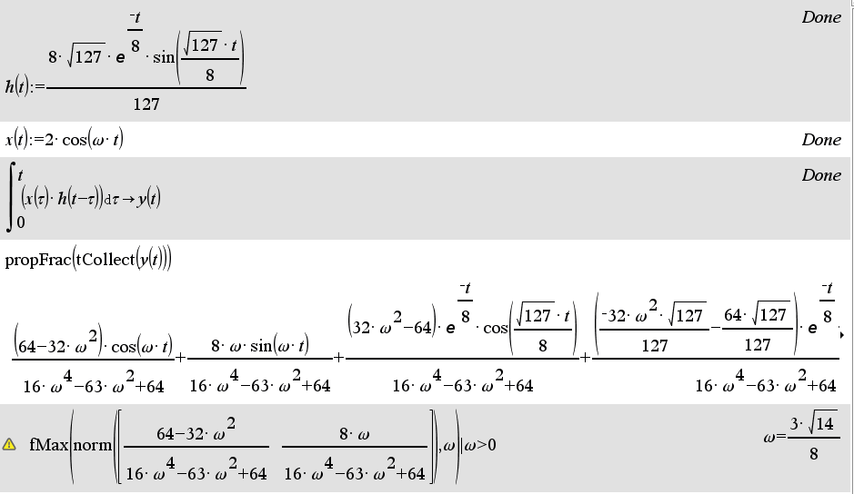 **Figure 4.6**